**Assignment 1 (50 points)- Due 09/09/21 @10:00 pm**

Both sections of this assignment should be completed in a Word document

**Part 1) Where are you on your Data Journey?**

 Share your data journey until the present

* List experience with math, data, research, and statistics.  List experiences from all parts of your life (home, fun, volunteer, school, work, and research)
* Which experiences were positive?  What worked well for you?
* Describe any challenges in your experiences.

Answer:

I have math, data, research, and statistics experience. When I studied in elementary, I started to study computers. Although I studied Basic programming language, I began to be interested in computers. While studying school, I was good at physics, math, and research. I have three years of working experience in filling out the forms and organizing the charts.

In my daily life, I go to church to volunteer. My family has an 81-year-old elder. I almost measure his blood pressure and scale every day. I knew the data on blood pressure and weight scale is tightly related to the health of elders. I care about others. I hoped that I could use my knowledge to help others recover from disease and get better.

**Part 2) Examine and explore Data Viz**

* Examine the following data source: DataViz <https://twitter.com/search?q=%23dataviz> and find a data visualization that meets the following criteria:
  + Relates to current events
  + Published less than 4 months ago
  + Provide links to the **original** source of the data
  + Visualization page needs to have a data source citation, not just the name of the citation “US Census”, for example. We need to be able to see the actual data source – where did the data come from?

Answer:

<https://data.cityofnewyork.us/Housing-Development/Multiple-Dwelling-Registrations/tesw-yqqr/data>

* Once you found the data, complete the following:
  + Write few sentences about your visualization and the data it displays
  + Submit the screenshot of your visualization into your Word document
  + Include the link to the page (URL for your viz)

Answer:

Using Tableau to explore and discover the distribution status of old buildings in New York City so that we can protect and maintain them better.

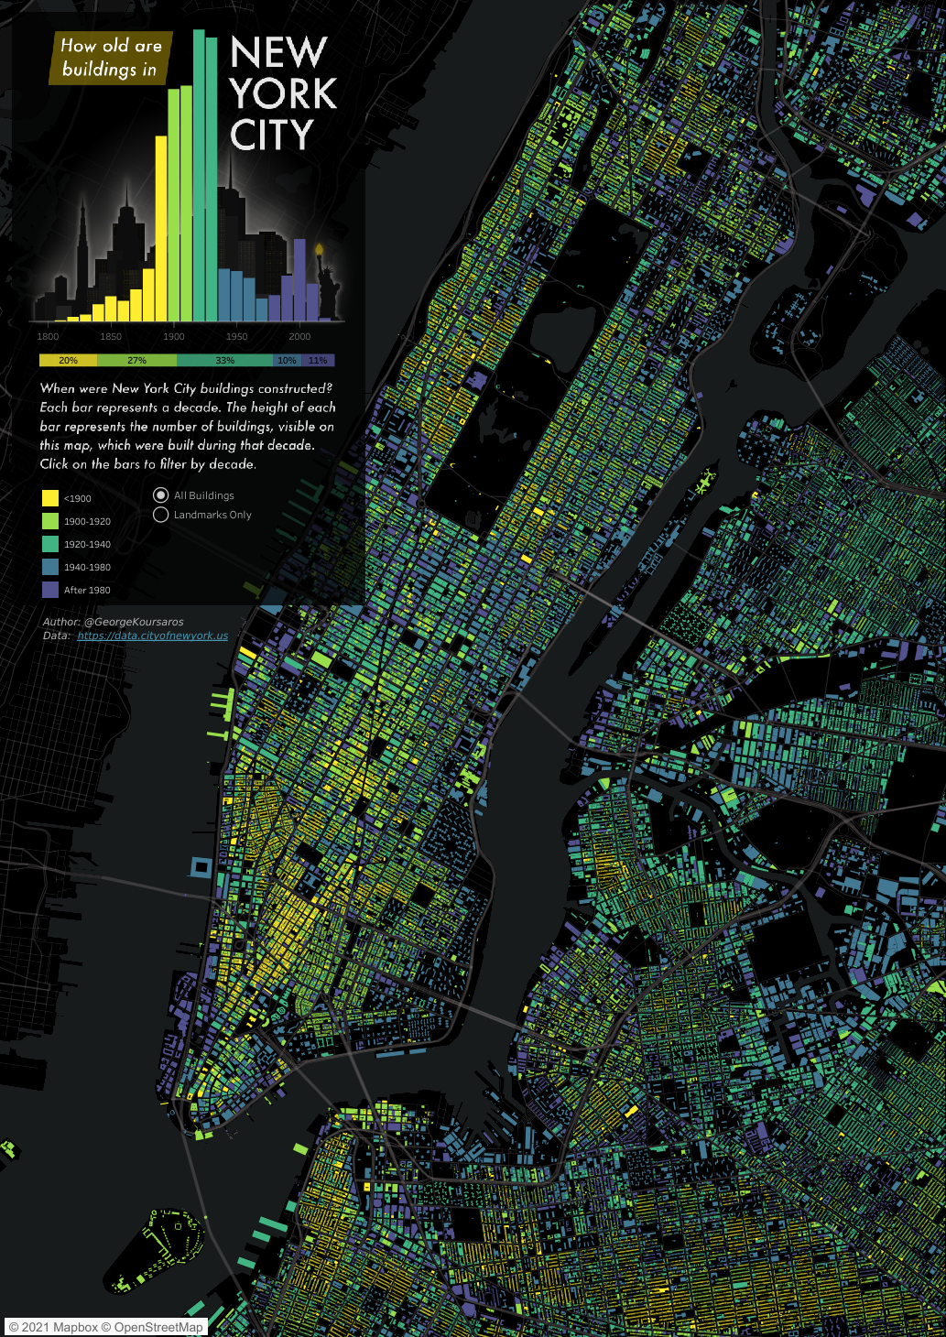

<https://public.tableau.com/app/profile/george.koursaros/viz/NYCBuildings_16222929546320/NYCBuildings>